NORTHWEST BLAZE BASEBALL CLUB
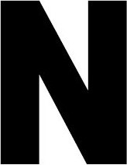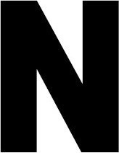
SPRING 2020

LEARN FROM EXPERIENCE

LOCATION:  THE YARD  25014 HIGHWAY 3 BELFAIR, WA 98528  AGES:  8-18  COST:  $175 ALL  SESSIONS | DATES:  JANUARY 11 – FEBRUARY 29  8 TOTAL SESSIONS  TIMES:  10:00 AM – 12:00 PM  CONTACT  TERREL HANSEN  360-710-9594 | All sessions will be led by instructors with professional baseball experience and will be teaching with the emphasis on each players' individual development. Players will be taught basic baseball fundamentals from throwing, hitting, fielding, baserunning, etc. as well as the mental side of the game.
Skills clinics are limited to 30 openings, sessions begin January 11th and continue Saturday’s through February 29th.

WWW.NORTHWESTBLAZE.ORG

